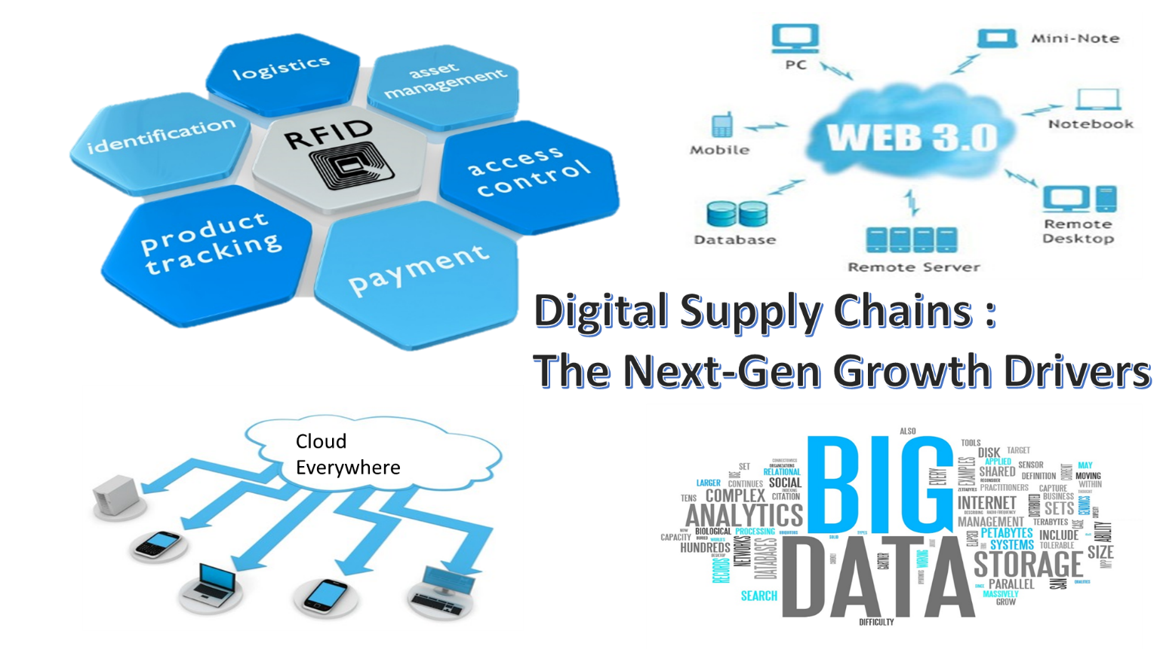

Introduction / Executive Summary:
For the sixth consecutive year, Apple has topped the annual list of top 25 supply chains published by the Gartner research firm. The criteria at the heart of the survey was based on the notion of demand-driven leadership. A journey from traditional "push" model of supply chain to the newer one that integrates consumers, suppliers, producers & distributors into a value based network. A network that generates a profitable response to ever-shifting changes in demand. In the study, two basic dimensions to determine the best performers were operational excellence and Innovation excellence. That means designing a self-improving system which continuously sense and respond to the supply chain disruptions. A system of technologies and processes which can handle the smallest of service glitches to larger disruptions like hurricanes, volcanos etc. Given the scale of the operations and level of globalization at which companies are working, this is increasingly evident that the modern supply chain is much larger than suppliers, distributors & customers; it also covers suppliers’ suppliers and customers’ customers. In reality, it encompasses a seemingly infinite set of variables and exposures and even a single failure anywhere in the supply chain can bring operations and profits to a standstill.
As the complexities of supply chains grow, need for innovative solutions rises. The traditional supply chains are no longer sufficient to handle the challenges of the new era. The answer lies in Real-time supply chains which are also called as digital supply chains. These supply chains facilitate multiple supply chain partners along the value chain to seamlessly interact in the joint designing, manufacturing, delivery and service of complex customer orders. In this white paper we try to explain the idea behind digital supply chains and their need to meet the challenges of ever increasing complexities of the new world. We will also try to explain how digital technologies can bring both operational as well as innovation excellence to the processes of any organization.

The Changing Operations Landscape

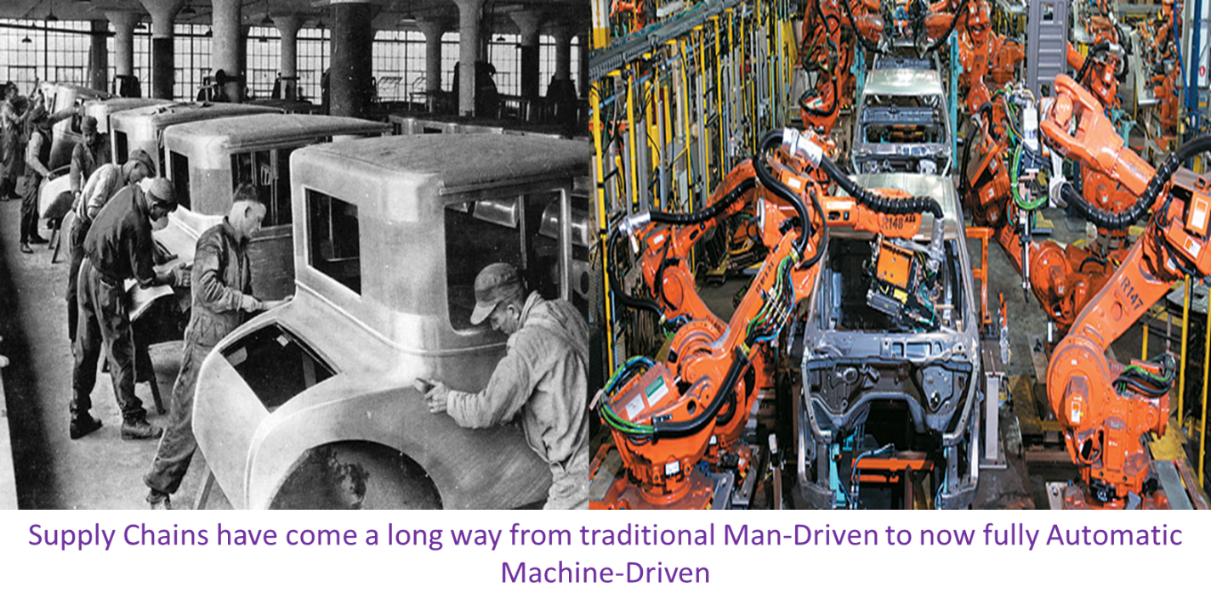
Managing supply chains has been a tightly contained and relatively easy task in past. During the early days of Industrial revolution, manufacturers established very basic supply chains and operated low precision and high-volume business models. Raw material that were procured by the rails or ships and factories were situated near the waterways to produce their own power to run their machines. The same mode of transport was used to send the finished goods to the different markets.
Later companies started to make their supply process vertically aligned to gain more control. They tried to bring most of the production and supply functions in-house to ensure the continuous & uninterrupted operations. Henry ford later capitalized on vertically integrated model of supply chain when he opened automobile production facility in Dearborn, USA. Iron ore and coal was supplied from Ford-owned mines via Ford freighters to Produce Ford steel. Thus he was able to capture the economies of mass production.
Companies started to internationalize in late 1950s, facilities were set up in foreign land to serve the local market and they followed the same production approach as in their home country.
Finally the true globalization started in 1980s and the supply Chain paradigm shifted entirely. Companies started to move to the regions where the manufacturing costs were lowest. Concept of lean manufacturing was introduced by Toyota and various other companies started to use method like Just-In-Time Inventory to improve their supply chain. The intention was to gain speed and cost reduction. Companies focused to remove redundancies from their business processes and outsourced non-core activities. This helped them concentrate on the areas which resulted in real competitive advantage. So far so good, companies were successful to fulfill the needs of their consumers. At the same time they were making good profits and were expanding to new markets.
Today technology is rapidly changing most of the consumer oriented businesses in their most fundamental way. Consumer demand patterns and buying behaviors are being significantly affected by ever increasing Internet penetration, instant information availability, and rapidly growing social networks. This has a significant impact on consumer oriented industries such as Retail, publishing, consumer electronics, entertainment, healthcare and financial services. But now this technology adoption by consumers have started impacting the supply chains in traditional industries which continue to produce only physical goods. Now there is a need for application of emerging technologies in supply chains, across industries, help organizations better fulfill the needs of their customers. That is where digital supply chains come into the picture. These chains have the capability for extensive information availability, and enable superior integration and communication across digital platforms resulting in improved reliability, responsiveness, agility and effectiveness. They help in removing traditional supply chain based functional and organizational silos which do not allow sharing information openly. Digital supply chains converts existing operating model to digitally operated model which enables organizations to gain much larger benefits by smart and continuous application of available standard technologies. We will explain such technologies further in coming sections.

Why Traditional Supply Chains are not equipped enough
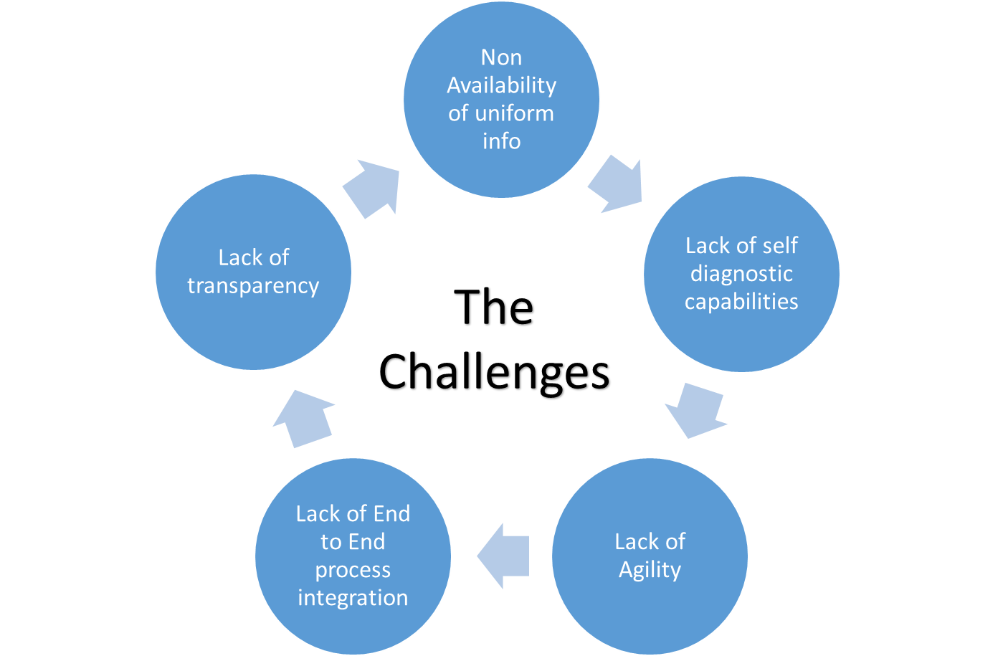
Traditional supply chains are liner supply chains which use hybrid supply chain models. These models are partly paper based and partly technology enabled. Linear supply chains are designed to cater to local customers via local factories. Even IT processes are also designed to cater to the local processes also called as functional islands. These different IT applications result in inconsistent and redundant data at corporate level. For a multi-national company operating in several countries, there will be hundreds of such applications generating huge but useless data for executives. Thus the biggest issue with the traditional supply chain is non availability of uniform & ubiquitous information. This does not allow management to take quick decisions and respond to the quickly changing scenarios.
Next biggest issue is related to failure of supply chains. Due to globalization, supply chains have a number of exposure or connection points which are prone to failures and break downs. Traditional supply chains do not have self-diagnostic capabilities. Thus it is very hard to pin point and fix the failure quickly. This results in operation lock down and it severely impacts the profits and customer relations.
End to End integration between different organizational units is not facilitated by traditional supply chains which hinders implementation of best or standard practices thorough out the organization.

Digital Supply Chain & its enablers
Not long time ago digital supply chain was referred to sales and distribution of digital products like e-books, MP3 files, Movie files etc. Sony, Amazon, Apple & Netflix were the first companies who introduced the idea that multi-million dollar products could be sold digitally or online. It was really a surprise for most of the companies as it provided an amazing proposition that product could be sold without physical supply chains and without transportation, manufacturing, warehousing & logistics costs. This has greatly reduced the cost to market for these digital products.
As Soon as the technology advanced the same proposition could be applied to most traditional type of supply chains which serves sectors like retail, healthcare, FMCG, automotive and almost every other known field. To do so there is a transition required from traditional supply chains to digital supply networks.
As quoted by Mr. Gary Hanifan, North American lead for Accenture's Operations group,” Digital supply network is a network that leverages SMAC (social, mobile, analytics and cloud) technologies, along with machine-to-machine digital conversations and instant visibility throughout the supply chain of information.”
These network integrates critical business systems from consumer portals to demand planning to supplier management to logistic management using high tech digital solutions. In the simplest way these network connect upstream and downstream supply chains using modern digital technology enabling uniform information flow throughout the value chain instantly. That is why digital supply chains are also called as real time or dynamic supply chains.
Below mentioned are the few technology enablers which have made digital supply chains a reality:
Advent of Automatic Identification and Data Capture technologies
Radio frequency Identification is the wireless technology which uses radio-frequency electromagnetic fields to transfer data, for the purposes of automatically identifying and tracking tags attached to objects. This technology has revolutionized the supply management process. It is used in automatic Warehouse Management Systems (WMS) to ultra-high tech Logistics & Distributions Systems. With RFID, the supply chain becomes considerably more precise which improves the efficiency and reliability of the entire chain. Administration and planning processes can be significantly improved as real-time information is available all the time. RFID tags can be automatically scanned without even being in the line-of-sight of scanner. Multiple tags can be scanned simultaneously which leads to cost reduction for manufacturers as labor intensive tasks can be completed faster and more accurately. RFID tags store far more info than conventional barcode systems which provides accurate movement of raw materials and time requirements. This greatly helps in production planning. Machine and equipment failures can be easily detected which helps in preventing costly production breaks and greatly reduce the maintenance and repair costs.
Walmart has been considered as top driver and early adopter of RFID technology. It has been using this technology from a decade. Initially sometimes its storekeepers were not able to find certain merchandise when it was needed which caused several headaches. The sprawling store warehouses could take hours to search, and once an item was found, the customer may not be around waiting for it anymore, translating into a lost sale for the company. By sticking RFID tags on products, the company was able to locate them wherever they were, and quickly. This has resulted in increased sales of around $287 million in the year of implementation of the technology. This is an example of around 8 years ago since then there has been more advancement in this technology and it has been fully adopted by digital supply chain solution providers.
Evolution of cloud-enabled platforms:
Cloud computing is a model for enabling ubiquitous, convenient, on-demand network access to a shared pool of configurable computing resources (e.g., networks, servers, storage, applications, and services) that can be rapidly provisioned and released with minimal management effort or service provider interaction (NIST Definition).
Digital supply chains will serve to, extended complex global networks. These network have tendency to be affected by continuous change in global business environment. This in turn creates a desire for agility and dynamic responses from the supply chains. Cloud will bring that aspect to the future supply chains. In the operation world this can also be envisioned as a social-media community of customers, manufacturers, transportation and logistics service providers, distributors etc.
Shippers, receivers and service providers all join the cloud-based community and readily connect to each other. You can go online and "friend" (now a verb) any chosen air carrier, railroad, truck line or ocean carrier. Just as easily, the service providers can friend its users, customers & clients. All you need to do is to tap into an existing network and enjoy the full benefits of the “Network” instantly.
For sharing anything, one only need to put core information, like news announcements, changes, contacts, scheduling, public pricing, service options and so on, out there once . Update of schedules, service or anything else is one time job. All trading partners can see the same information at the same time. It is like utilizing the “Network” feature to full extent. A fully integrated, network-based community of trading partners will provide the foundation to drive business intelligence in terms of visibility and event management.
Cloud platform can provide complete end-to-end visibility, preferably at the SKU level. Once you have that, you can see into your supply chain and determine what's causing the most common disruptions like Transit-time variability. These variability forced companies to carry higher inventory levels. Once the cause for the disruption is removed inventory could be maintained at minimum level, one of the feature of digital supply chains.
SaaS (Software as a service), PaaS (Platform as a service), SOA (Service Oriented architecture) are few of the services provided by the cloud platform. These service will help in designing automated Sales & Operations Planning (S&OP), Transportation Management Systems (TMS), Spare Parts Management, Store Shelf Optimization systems at very low cost. Further all these system will provide a “single view” of the value chain to the management thus helping those taking critical decisions. Thus cloud provide greatest potential to deliver the network effect throughout a supply chain.
Rising Application of Big Data with different Analytics techniques:
It’s likely that almost every fortune 500 firms already has a substantial amount of data that has accumulated over the past several years. This includes structured, semi-structured, unstructured, partner, macro, micro, internal, external every type of data. That is why this is called as big data. Not so long ago this was considered as a liability as daily demands, limited resources, and Legacy ERP systems usually make it difficult to easily view, manage, report, and analyze this wealth of information. But when coupled with different analytics technique like Descriptive, Prescriptive, Predictive and Cognitive, this will work as brain for the digital supply chains.
Descriptive Analytics is about describing the historical performance. By applying these techniques to the level of performance, information can be very specific to product, customer, channel, supplier and other key operational areas of focus. This will help validate data to be organized and be used in a repeatable process, in order to have confidence in the information and to make it actionable. This will help companies to evolve from “standard cost to serve” approach to “total cost to serve” approach thus identifying immediate cost and revenue opportunities and take confidant action to utilize them.
Prescriptive Analysis is about identification of optimum business outcomes by combining historical data, mathematical models, variables, business rules, constraints, anticipated customer requirements, machine-learning algorithms. It is also used when experimenting in the real world would be very expensive or overly risky, or require too much time. Many airline ticket pricing systems use this analytics to sort through complex combinations of travel factors, demand levels, Supply constraints and purchase timing to present potential passengers with prices designed to optimize profits at the same time maintaining the sales levels.
Predictive Analysis is about predicting the future, unknown events, failure points based on statistical techniques. Predictive analytics enable Demand Driven Value Networks (DDVNs) through segmentation, demand sensing and shaping, and profitable response. This will help to transform the SCM model that was earlier based on aggregate information, averages and generalized models into a customized response based on the basis of unique characteristics of customers, products or suppliers or any other supply partners.
Cognitive Analysis This type of analytics combine human experience with machine level performance. This is the new area which offers amazing new opportunities to positively impact financial performance. Advances in Cognitive Analytic capabilities & machine driven learnings that get smarter over time, has the potential to further drive innovation and competitive advantage. Additional advantage of Big Data in future will be derived from blending the intelligence of the people who have deep understanding of operations, with the power of increased machine driven operational insights.
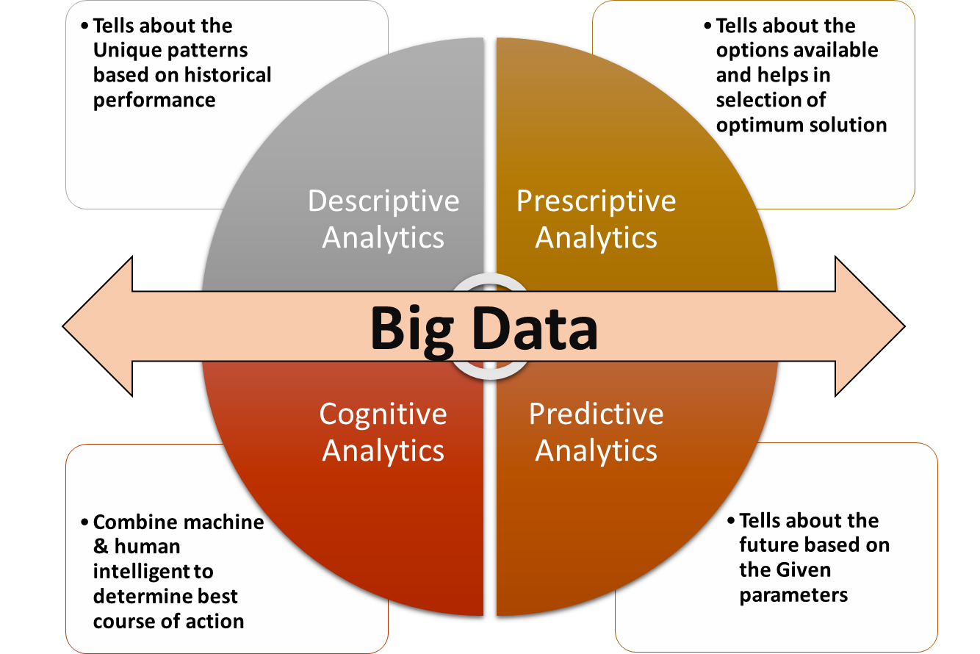
Big data used well with the analytics techniques will provide the digital SCM with great answers and also provide valuable help in doing faster and better business in future’s data driven world. Tighter integration, management and analysis of these databases using big data can be helpful to improve efficiencies of inventory management, sales and distribution process and continuous monitoring of devices. Predictive maintenance of equipment is another benefit which will be given by modern supply chains using the Big Data & Analytics.

The Internet of Things:
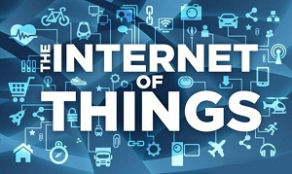
The Internet of Things (IoT, for short) is a phenomenon used to explain the scenario when everyday multiple objects are connected to the internet and participating together on a system, continuously sharing the information. It also means the convergence of conventional connected devices and smart appliances. Kevin Ashton coined the phrase "Internet of Things" while working for Procter & Gamble in 1999. IoT is converting the physical world into a type of information system with sensors and actuators embedded in physical objects and linked through wired and wireless networks via Internet Protocol. As per a Gartner Report, the “Internet of Things” is forecast to reach 26 billion installed units by 2020, up from 0.9 billion just 5 years ago, and will impact significantly the information available to the supply chain planner. The impact is being considered so huge that this is being seen as pioneer of the fourth industry revolution following the steam engine, the conveyor belt, and the first phase of IT and automation technology.
Sensors sending continuous data stream with real-time information processing technology based on RFID etc. can realize real-time monitoring of almost every link of the supply chain ranging from product design, raw material purchasing, Production planning & execution, transportation, storage, distribution and sale of products, reverse logistics and after sales service. With IoT, it will be possible to obtain products related information so promptly and accurately that the whole supply chain can respond to the changeable market conditions and supply disruption within shortest amount of time. One example of its other usages is where one company's product becomes another company's intelligent asset, with the potential for remote monitoring to optimize service and to improve the design of the product, based on field observations. Smart goods facilitates the extension of the supply chains so that monitoring services, content and other digital services extend beyond the shipment of the good and into the customer's environment which ensure the continuous feedback and tracking of product behavior.

3D Printing:
3D printing, also called as additive manufacturing, is a process of making three dimensional solid objects from a digital file. The manufacturing of the object is achieved using additive processes. In this process an object is created by laying down successive layers of material until the entire object is created. 3D printing is the technology which will to a great extent help to realize the actual potential of the digital supply chains. The supplier will be no longer providing finished goods rather raw materials will be distributed to manufacturing sites equipped with 3D printers, that will produce parts on demand to be used in product assembly. Companies will be able to decentralize their manufacturing and establish distribution channels much closer to the point of sale (POS). The potential for 3D printing to change the inventory levels from finished goods to raw materials can reduce the overall cost of carry throughout the supply chain. Since Raw materials pose a much lower inventory cost profile than finished goods. In addition, the cost of carrying parts purchased from a supplier will be greatly reduced as finished goods can be deferred by fabricating a part or component when and where it is demanded using a connected 3D printer.

Google Glass: Google Glass is a wearable glass operating on chip based technology similar to a smart phone. As of now using voice commands, Google Glass has the ability to connect to a variety of Internet sources & applications and then display the data in front of the wearer’s eyes. Users can quickly gain access to a plethora of information without having to reach for a phone, tablet, or computer. This feature of these glasses can be used in various systems operates across product life cycle.
This type of technology goes way beyond simply tracking the location of the product rather related information such as supplier relationships, maintenance, depreciation, usage patterns, purchase price, and productivity is provided. This enables users to manage all aspects of product. Google Glass will be used help guide warehouse operatives to store operations within a warehouse and display product information.

Fields which will be revolutionized by digital supply chains

As we have explained in previous section digital supply chains can deliver insights from big data and enable organizations to react quickly to threats and opportunities. That results from the flexibility that is inherent in the adaptable structural design of the chain. These chains use information gathered from almost all relevant sources to facilitate fast innovation, thereby reducing the time required to design, develop and take new products and services to market.
The Digital Supply Network is connected to the end consumer. As companies sell products, information can be shared across the supply chain, helping retailers and manufacturers keep an eye on inventory. And as customers seek information about products or services they buy, companies can have information more readily at their fingertips to reassure the socially responsible consumer about how something was made and the raw materials that were sourced.
Physical assets such as plant and equipment will remain central to manufacturing as of now but these can be intertwined in the Digital Supply Network, which is empowered by mobility solutions, the cloud, social media and analytics & big data.
Following are few of the complex areas where digital supply chains can provide astonishing result and help organizations overcome the persistent challenges.

Rising Market for Reverse Logistics
Reverse logistics is defined as the system of moving products or components for their point of consumption(customer end) to point of origin (Manufacturing end) through channel members for the purpose of recapturing value or disposal. Reverse logistics processes and plans rely heavily on reversing the traditional forward moving supply chain. The area of reverse logistics includes return policy administration, product recall protocols, repairs processing, product repackaging, parts management, remanufacturing, recycling, product disposition management, refurbishing, maximizing liquidation values and much more. As per a Gartner report, total reverse logistics market is more than 50 billion dollar in USA alone.
Many companies still continue to view reverse logistics as a burden to their organization. However they should understand that reverse logistics is a critical link to their supply chain. Most of the issues related to reverse logistics can be easily resolved by digital supply networks. As they have self-diagnosing capabilities it would be easy to identify where the process went wrong: was it the product itself, the size, the color or possibly a bad customer experience. This approach offers opportunity to mine the data, learn and provide better customer insights which will reduce the volume of return in future.
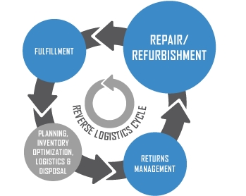
Digital supply chains ensure speedy response which we can understand from an incident at Earthbound Farm Organics in late 2012. A strain of salmonella was able to breach into the supply of the country's largest organic peanut processing plant outside Portales, New Mexico. The result was a quick and massive recall of every jar of organic peanut butter sold at retailers around the world. It was due to a blip which appeared on the software screens of emergency reverse logistics system at Earthbound Farm Organics. Earth bound’s supply chain platform is a high-tech RFID tracking system that tracks the movement of every head of the 140 million pounds of lettuce it produces every year from its global network of farms all the way to the customers that bring them home. It is a system called as "farm-to-fork traceability" (Charlie Sweat, CEO Earthbound) and it was that system that created the blip. This system allowed Earthbound to carry out a targeted recall of the specific contaminated products long before any official word had been issued and before anyone got sick. Digital supply chain provides real-time traceability and identification of products across the chain. This brings visibility into every step of the product life cycle from how it is produced, where it is produced, when it was produced, where it was sold and who buys it. Every single detail thus can handle reverse logistics very efficiently.

Pervasive Visibility
The world is moving from Collaborative planning, forecasting, and replenishment (CPFR) concept to more cohesive integrated approach which will provide organizations visibility to each and every minute activity and vice versa. On similar lines, BOSH is currently developing a software operated virtual supply chain. The environment will take the output from various RFID and other sensors located across both their factories and their 3PL providers and this will provide a complete end to end view of shipments as they move from point of manufacture to point of delivery. Now when we couple RFID with IoT (Internet of Things) then we can have web with multiple interconnected devices informing each other about every single activity, diagnosing, doing self-maintenance and generating report without any human intervention. Only digital supply can ensure such high level of visibility.

Corporate Social Responsibility initiatives
Four Decades ago the famous economist and Nobel laureate Milton Friedman referred to corporate social responsibility (CSR) programs as “hypocritical window-dressing,” and commented that business leaders inclined toward such programs “reveal a suicidal impulse.” At that time his views were echoed by most of the people around the world but today the scenario has changed. A decade ago only few of fortune 500 companies had issued their sustainability report. But now almost every one of them does that. Around 8,000 businesses across the world have signed the UN Global Compact, pledging to show good global citizenship in the areas of human rights, environmental protection & labor standards. According to CorporateRegister.com, more than 5,500 companies around the world issued sustainability reports in 2012, up from about 800 a decade ago.
This all is happening because consumers are increasingly tuned in to sustainability when making their buying decisions. They are more educated now. They are no longer hidden from processes about how their food is produced or how their iPads are made. And because of things like social media, like-minded people more easily find each other, have their say and effect change. We are living in the Electronic Age where information about any company’s environmental record, labor practices is readily available and readily tweeted and retweeted — companies must pay careful attention to what their customers do and say.
Now corporate social responsibility leaders is being increasingly held accountable for responsible behavior all along their supply chains. However to implement CSR seriously, it has to be integrated into the values of the enterprise and the immediate channel for this is company’s operations practices and its supply chains. Suppliers’ CSR performance can significantly impact the operational, reputational, and financial success of their customers. There is more pressure than ever for companies to implement practices that increase transparency, remove corruption, enhance environmental sustainability, protect human rights, and ensures ‘local content’ objectives in the supply chain. Digital supply chains will help companies to set clear expectations, establish assurance mechanisms, and balance cost implications of managing their supply chain. It will bring in amendments and new procedures for monitoring, oversight, and reporting. These supply chains will also ensure greater coordination between customer and supplier which is required to achieve intended outcomes and benefits.
CSR in India: A Paradigm shift
There is been a milestone law passed In India which will compel companies to take the CSR initiatives to new heights. As per section 135 of Indian companies Act 2013, large and medium-sized Indian companies will have to spend 2% of their profits on CSR initiative. India will now be the inventor and incubator for new initiative, methods, models and paradigms for tackling its most intractable, overly complex and persistent problems. It’s a breakthrough decision of Ministry of corporate affairs, India which has decide to keep decision making power with companies to decide & implement processes to bring in social and environmental changes. By making directors’ involvement in CSR policy governance and implementation a mandate, the Companies Act, 2013 is elevating the status of CSR and helping to ensure that it is governed by people with decision making power and expertise in the strategic and operational aspects of the company as a whole.
Now rather than focusing merely on fund disbursement, companies can now use this opportunity to leverage their core & unique capabilities and forge multi-stakeholder partnerships to address of the problem. Ecosystems will need to be created to enable differing interventions and players to interact and work together towards a unified goal. A well-established digital supply chain and distribution technologies can be used to support delivery of goods and services to meet different societal needs. There are many cases in which aid is available from governmental or other agencies, but the challenge of distributing the aid to those in need is prohibitive. This is the area where digital technologies will help to realize these things. These technologies will ensure companies continue to earn profit from their supply chain while keeping their CSR initiatives implementing. From fuel reduction to last mile reach to reduced ecological footprint to intact collaboration among the partners to CSR initiative implementation, everything will be facilitated by digital supply chains.

Conclusion:
The transformation from traditional supply chains to Digital Supply Networks is taking place at high speed to achieve resilience, agility, sustainability and responsiveness, as well as the operational efficiencies. Many companies have already started to channelize their efforts in this direction. Don’t be left behind. It’s time to disrupt your market and visualize your success with an end-to-end Digital Supply Network that helps you integrate with partners, suppliers and customers to add value to your company’s bottom line.
Contact Us
Gray Routes Innovative Distribution LLP,
4A9, Gundecha Enclave, Kherani Road,
Andheri (E), Mumbai - 400072
Tel: + 91 22 2852 3871
Mob: +91 773838 9572
Email: info@grayroutes.in

Visit our website at
http://www.grayroutes.in

About GrayRoutes
Gray Routes Innovative Distribution LLP, founded in March 2013, is an agile startup with a transformational agenda. Leveraging the immense power of GPS Technology to unearth innovative business models, Gray Routes provides distribution technology consulting and application-specific mobile app & analytics solutions to some of the largest FMCG, telecom, food services, e-Commerce and logistics companies completely transforming their sales and distribution management systems.

References:
http://www.rfidarena.com/2013/11/14/benefits-of-implementing-rfid-in-supply-chain-management.aspx
http://www.networkworld.com/news/2007/101207-wal-mart-eyes-287-million-benefit.html
http://www.supplychaindigital.com/outsourcing/cloud-computing-in-the-supply-chain
http://onlinelibrary.wiley.com/doi/10.1111/jbl.12010/pdf
http://www.mckinsey.com/insights/business_technology/the_internet_of_things_and_the_future_of_manufacturing
http://www.gxsblogs.com/morleym/2014/03/how-the-internet-of-things-will-provide-fuel-for-future-digital-supply-chains.html
http://supplyon.com/en/vendor-managed-inventoy_at_bosch.html
https://www.ashgate.com/pdf/SamplePages/ghsupplych2.pdf
http://ejournal.narotama.ac.id/files/Corporate%20social%20responsibility%20in%20global%20supply.pdf
http://www.dasra.org/csr-guide.pdf
http://www.forbes.com/sites/forbesleadershipforum/2012/01/18/the-top-10-trends-in-csr-for-2012/

